PROTECTIVE EFFECTS OF VITAMINS C AND E ON CISPLATIN – INDUCED RENAL DAMAGE IN ADULT ALBINO RATS (A Light and Electron Microscopic Study)
Saadia A. Shalaby MD. ,Esam M. Eid MD. , Naglaa A S.
Sarg MD. ,Mohamed M. Qonswa (M.B.B.CH.)
Department of Anatomy ,Faculty of medicine ,Benha University ,Egypt
Abstract
Background: Cisplatin is an effective chemotherapeutic agent used in the treatment of a wide variety of solid tumors .The major side effects limiting its clinical use is the nephrotoxicity.
The aim of this work: was to study the possible protective effects of vitamins C and E on Cisplatin-induced nephrotoxicity in adult albino rats.
Materials and Methods: Thirty adult male rats were divided into three equal groups: The control group, Cisplatin group and Cisplatin plus vitamins C and E group .In the control group ,the rats were injected intraperitoneally with 2ml of normal saline /kg .B. W. once daily for 3 consecutive days. In Cisplatin group , the rats were injected intraperitoneally with Cisplatin at dose of 10mg /kg .B.W. once daily for 3 consecutive days. In Cisplatin plus vitamins group, the rats were injected intraperitoneally with Cisplatin as the second group ,in addition to vitamins C and E at dose of 250mg/kg .B.W .each. The vitamins were administrated orally with a cannula one hour prior to Cisplatin injection. All animals were sacrificed 3 days after the last injection .The kidney specimens were prepared for light and electron microscopies.
Results: Cisplatin produced necrosis of the epithelial lining of most of the proximal convoluted tubules with subsequent dilatations of their lumens .Some of these tubules contained esinophilic material .The epithelial cells of some tubules contained many vacuoles .The Cisplatin induced focal condensation of the connective tissue and inflammatory cells in the interstitial spaces. Electron microscopic examination showed that Cisplatin produced reduction in the numbers of mitochondria and the microvilli with increase the numbers of lysosomes ,vacuoles and vesicles. Cisplatin obliterated the pores in the glomerular endothelium and in between the foot processes of the podocytes. Administration of vitamins C and E during the Cisplatin injection reduced the pathological changes induced by Cisplatin. The severity of these changes in the tubules and the glomeruli were less than those in the Cisplatin group.
Conclusion: The toxic effects of Cisplatin on the kidney was minimized by administration of combination of vitamins C and E .
Keywords: Cisplatin, nephrotoxicity, vitamins C and E ,rat kidney.

Introduction
Cisplatin is a platinum –containing antineoplastic agent . It is one of the most potent chemotherapeutic antitumor agents . It has been demonstrated against a variety of neoplasms, particularly for head and neck, testicular , ovarian , bladder and lung neoplasms ^{(1,2,3)} . High doses of Cisplatin produce hepatoxicity, otoxicity, neurotoxicity and nephrotoxicity ^{(3,4,5,6,7,8)}.
Cisplatin – induced renal damage is associated with increased renal vascular resistance and histological damage to the proximal tubular cells^{(3,9)} . Cisplatin – induced nephrotoxicity is closely associated with inhibition of the activity of antioxidant enzymes in renal tissues^{(8,10,11)}.
Vitamin C acts as a potent water – soluble antioxidant in biological fluids⁽¹²⁾. It may prevent oxidative damage to important biological macromolecules such DNA ,lipids and proteins⁽¹³⁾ . High doses of antioxidant vitamins C and E were demonstrated to be effective against Cisplatin –induced oxidative renal damage in rats^{(14,15)} .However , few papers have reported the effects of vitamins C and E in Cisplatin treated rats. So , the present study has been performed to investigate the possible protective effects of vitamins C and E on Cisplatin nephrotoxicity in adult albino rats.
Materials and Methods
A- Chemicals:
1- Cisplatin (platinol) is produced by Orna Chemicals and Pharmaceutics. It is in the form of vials. Each vial contains 10mg/ 20ml of Cisplatin . The dose of Cisplatin used in this study was 10 mg /kg. B. w.
2- Vitamin C (cevarol tablet) is produced by Memphis Chemical Company .Each tablet contains 500 mg ascorbic acid .One tablet was dissolved in 10ml distilled water .Each 1ml =50 mg. The dose of vitamin C used in this study was 250 mg/kg.B.W.
3-Vitamin E (E- viton capsule) is produced by Kahira Pharmaceutical Company. Each capsule contains 100mg vitamin E. The 5 capsules (500mg)were pinched using the tip of a sterile needle ,the contents were squeezed and dissolved in 10ml olive oil .Each 1ml =50mg of vitamin E. The dose of vitamin E used in this study was 250mg /kg. B.W.
B- Animals:
Thirty adult male albino rats were used in this study. Their ages ranged from 2.5-3 months old. Their weight ranged from 200-250gm .They were fed daily with tap water and pellet foods at room temperature.
C-Experimental design:
The animals were divided into three groups of ten rats each.
Group I (control group) were injected intraperitoneally with 2ml of normal saline/kg. B.W. once daily for 3 consecutive days.
Group II (Cisplatin group) were injected intraperitoneally with Cisplatin at a dose of 10mg /kg. B.W. once daily for 3 consecutive days.
Group III (Cisplatin plus vitamins group) were injected with Cisplatin as the second group, with oral administration vitamins C and E at a dose of 250 mg/kg each. Vitamin C was dissolved in distilled water ,while vitamin E was dissolved in olive oil. Vitamins C and E were administrated orally with a cannula one hour prior to Cisplatin injection.
All animals were sacrificed 3 days after the last injection using ether anesthesia .
D-Histopathological procedures :
The kidneys of all groups were excised and washed with saline to remove the blood . The kidney specimens were processed for light and electron microscopical examination . For light and electron microscopical observation, the kidney sections were stained with Hematoxylin and Eosin ,Masson´s trichrome and Periodic acid –Schiff (P.A.S.) .The sections were photographed using a Camera connected with light microscope . For electron microscopical observation ,ultrathin sections were collected on copper grids for double staining(uranyl acetate and lead citrate ). Stained sections were finally observed under a transmission electron microscope and photographed.
Results
Control group:
By light microscopy, the histological structure of the renal cortex of the control group showed the normal structure of both glomeruli (renal corpuscles)and tubules. Each glomerulus appeared as a dense rounded structure which was surrounded by narrow space called renal space(Bowman´s space). The glomerulus consisted of tuft of capillaries which was covered by the Bowman´s capsule. The Bowman´s capsule consisted of an inner or visceral layer covering the glomerulus and an outer or parietal layer and the renal space in between. The visceral layer consisted of epithelial cells called the podocytes. These cells had large deeply stained nuclei .The parietal layer was composed of simple squamous epithelium resting on a thin basal lamina(Figs.1,2).
The tubules which were seen in the sections consisted mainly of the proximal convoluted tubules and some distal convoluted tubules .The proximal convoluted tubules had narrow lumens and were lined by a single layer of columnar cells with rounded ,basal ,vesicular nuclei . The distal convoluted tubules had wide lumen and were lined by low cuboidal cells (Figs.1,2).
P.A.S. positive reaction was evident in the basement membranes of the parietal layer of the Bowman´s capsule and the tubules . Also, the brushing border of the tubules showed positive P.A.S. reaction (Fig.3).
By electron microscopy , the proximal convoluted tubules were lined by columnar cells which had rounded heterochromatic nuclei with prominent nucleoli. Its cytoplasm contained columns of elongated mitochondria resting on the basement membrane. At high magnification, the wall of mitochondria had double membranes with translucent space in between .The lumens of the proximal convoluted tubules revealed profuse tall microvilli constituting the brush border seen by light microscopy (Figs 4,5).
The glomerular filter consisted of three components (inward to outward): 1-Fenestrated capillaries endothelium.2-Glomerular basement membrane . 3-secondary foot processes of the podocytes, separated by slit pores (Fig.6) .
Cisplatin group:
By light microscopy ,most of the proximal convoluted tubules showed necrosis of their epithelial lining which lead to dilations of their lumens . Some of these degenerated tubules contained esinophilic material which accumulated in their lumens . Some of these epithelial cells contained vacuoles and their brush borders were disrupted in some areas .Few tubules were still intact .The glomeruli appeared intact with intact basement membrane of its parietal layer .The interstitial space contained focal accumulation of connective tissue . In some sections there were focal accumulation of inflammatory cells in the interstitial space (Figs.7,8,9,10) .
By electron microscopy ,the convoluted tubules showed increase in the numbers of lysosomes , vacuoles and vesicles .The contents of some lysosomes were homogenous ,while the others were heterogeneous. The cytoplasm of these cells contained few numbers of mitochondria Some nuclei showed basal indentation .The lumens of these tubules contained few microvilli (Figs.11,12) .In the glomerular filter, there were absence of the fenestration in the capillary endothelium and obliteration of the slit pores between the secondary foot processes of the podocytes (Fig. 13) .

Cisplatin plus vitamins( C & E ) group:
By light microscopy ,the glomeruli and some tubules were intact . other tubules had varying degrees of changes in the form of 1- Some tubules were dilated with intact epithelial lining .2-Other tubules were not dilated ,but some of their cells had vacuolations .3-The lumen of one tubule contained esinophilic material . 4-The epithelial lining of few tubules were completely degenerated ,but their basement membranes were intact (Figs. 14,16). Minimal connective tissue were seen in the sections of this group (Fig. 15) .
By electron microscopy , the elongated basal columns of mitochondria were seen in the cells lining the tubules. Their nuclei were heterochromatic with prominent nucleoli (Fig. 17). The components of the glomerular filter consisted of three layers as in control group: fenestrated glomerular endothelium ,glomerular basement membrane and foot processes of podocytes with slit pores in between (Fig.18).
Figures 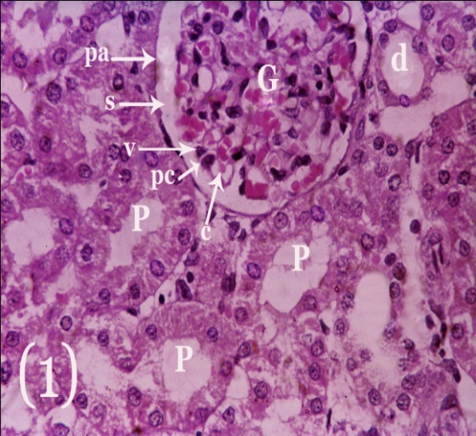
Fig.1:A light micrograph of adult control rat kidney showing :The glomerulus (G),the proximal convoluted tubules(P) and the distal convoluted (d).The glomerulus consists of capillary tuft (c),visceral layer of Bowman´s capsule(V) which separates from its parietal layer (pa)by renal space (s). Notice the podocytes (pc)with deeply stained nuclei in the visceral layer of Bowman´s capsule. The parietal layer was composed of simple squamous epithelium resting on the basement membrane .The proximal convoluted tubules consist of columnar cells with rounded basal vesicular nuclei. The distal convoluted tubules have low cuboidal cells with vesicular nuclei and wide lumen. (HX &E. X400)

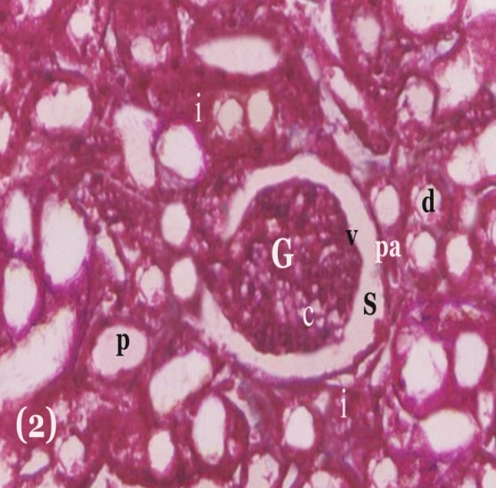
Fig. 2: A light micrograph of adult control rat kidney showing : The glomerulus (G)consisting of tuft of capillaries (c) , visceral layer (v),renal space (s) and parietal layer (pa). The glomerulus is surrounded by cut sections of the proximal(p) and distal (d) convoluted tubules. The interstitial space (i) is rose in colour. (Masson´s trichrome x 400)

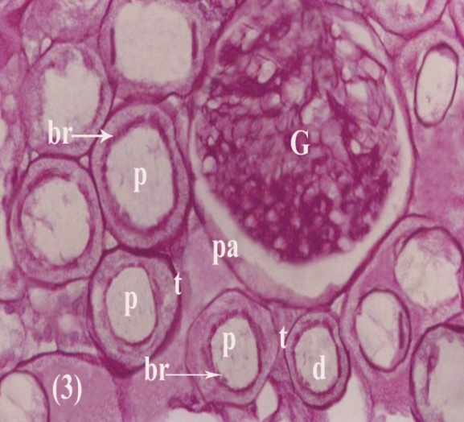
Fig. 3: A light micrograph of adult control rat kidney showing : The glomerulus (G) surrounding by proximal(p) and distal (d) convoluted tubules .Notice a well defined basement membranes of the parietal layer of Bowman´s capsule (pa) and the convoluted tubules(t).Also, notice a well defined brush border(br) in the proximal convoluted tubules. (P.A.S. X400 )
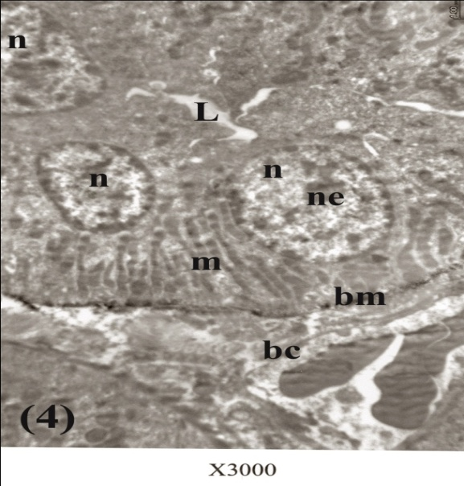
Fig.4: An electron micrograph of adult control rat kidney showing: A part of the proximal convoluted tubule lining with columnar cells. These columnar cells have rounded ,heterochromatic nuclei(n) with nucleoli (ne) and columns of elongated mitochondria(m) resting on the basement membrane(bm) .Notice a narrow lumen (L) of the proximal convoluted tubule .The interstitial space contains blood capillary(bc) . (E. M. X3000)
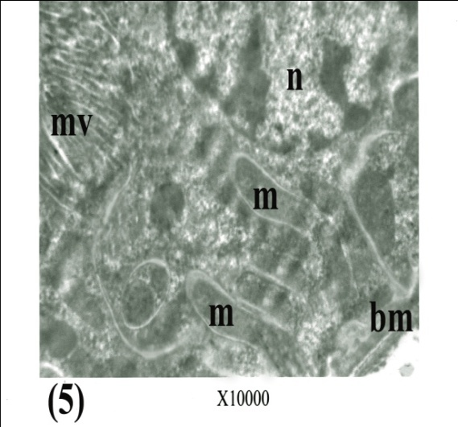
Fig.5: An electron micrograph of adult control rat kidney showing: A part of the proximal convoluted tubule containing heterochromatic nucleus (n) , elongated basal mitochondria(m) resting on the basement membrane(bm). Notice the wall of mitochondria has double membranes with translucent space . Also, notice the microvilli(mv) projecting into the lumen . (E.MX10,000) 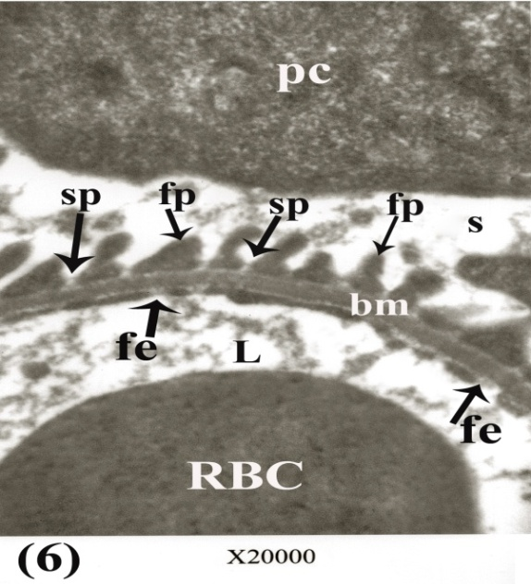
Fig.6: An electron micrograph of adult control rat kidney showing: The components of the glomerular filter consisting of fenestrated capillary endothelium (fe) , glomerular basement membrane (bm) and secondary foot processes (fp) of podocytes(pc) which separated from each other by slit pores (sp) . Notice the lumen(L) of the glomerular capillary containing RBCS. Also, notice the renal space (s). (E.M. X 20,000)
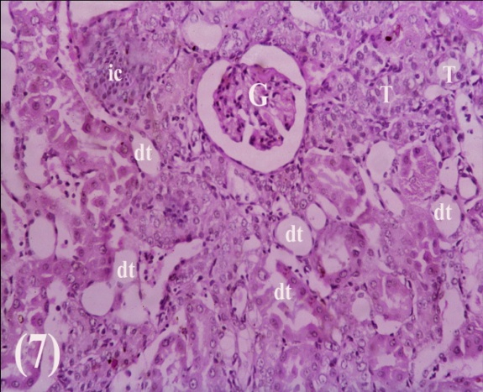
Fig. 7: A light micrograph of adult rat kidney treated with Cisplatin showing : Most of the cells of tubules are degenerating (dt) with dilatations of their lumens. Notice the interstitial space containing focal accumulation of the inflammatory cells(ic). Also, notice intact glomerulus(G) and some tubules (T). (HX .&E. X 200)
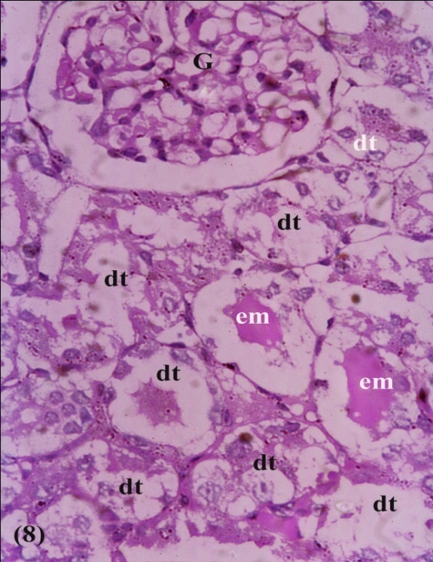
Fig. 8: A light micrograph of adult rat kidney treated with Cisplatin showing : Degeneration of the epithelial cells lining the tubules (dt). The lumens of some tubules are dilating with accumulation of esinophilic material (em). Notice the intact glomerulus (g) . (HX .&E. X 400)
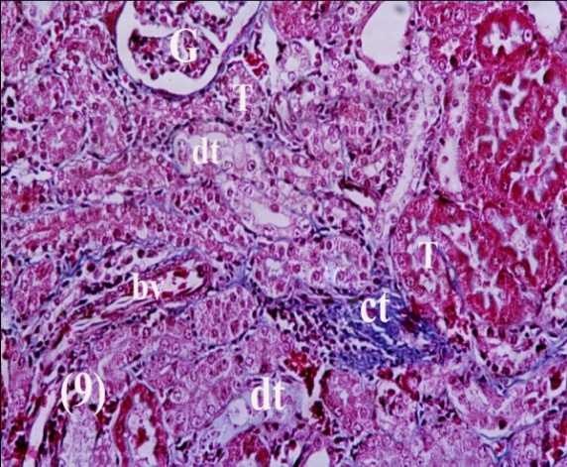
Fig. 9: A light micrograph of adult rat kidney treated with Cisplatin showing : Focal accumulation of the connective tissue (ct) in the interstitial space. Some tubules(dt) are degenerating ,which other tubules (T) are intact . Notice the glomerulus(G) and blood vessel(bv). (Masson´s trichrome x 400)

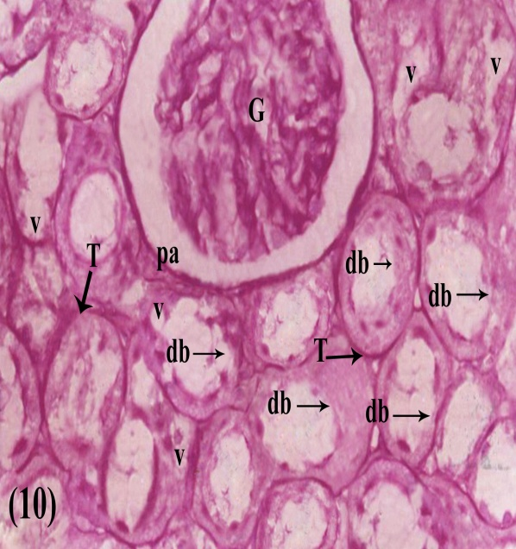
Fig.10: A light micrograph of adult rat kidney treated with Cisplatin showing :Partial disruption of the brush border (db) of the tubules. Some vacuoles(v) are seen in the epithelial cells lining the tubules . Notice intact basement membranes of the tubules(T)and the parietal layer (pa) of the glomerulus(G) . (P.A.S. X400 )
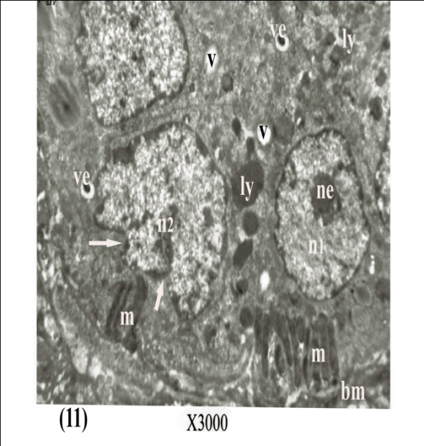
Fig.11: An electron micrograph of adult rat kidney treated with Cisplatin showing: Less number of basal mitochondria (m) resting on the basement membrane (bm). The cytoplasm contains different sizes of lysosomes (ly), vacuoles (v) and vesicles (ve) . Notice rounded nucleus (n1) with central nucleolus (ne), while other nucleus(n2) has basal indentation (arrow) . (E.M. X 3000)
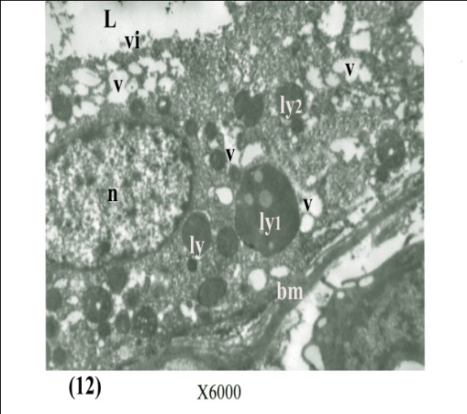
Fig.12: An electron micrograph of adult rat kidney treated with Cisplatin showing: The cells of the proximal convoluted tubules containing different sizes of lysosomes (ly). Some of these lysosomes are heterogeneous (ly1), while other lysosomes are homogeneous(ly2). Also , the cytoplasm of this cell contains groups of vacuoles (v) and oval intact nucleus (n) . Notice the lumen (L)of this tubule containing few microvilli(vi) . Also notice the basement membrane (bm) . (E.M. X 6000)
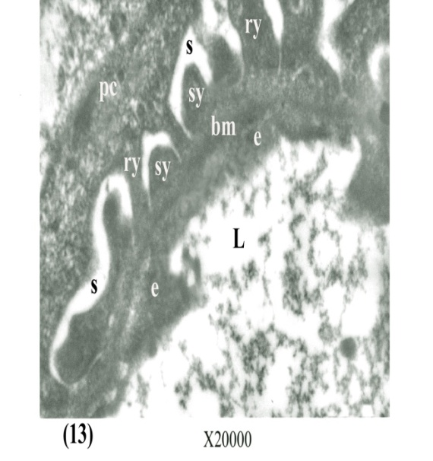
Fig.13: An electron micrograph of adult rat kidney treated with Cisplatin showing: Absence of the fenestration in the capillary endothelium (e) and slit pores in between the foot processes ( primary"ry" , secondary "sy" ) of the podocytes (pc) . Notice the lumen (L) of glomerular capillary , glomerular basement membrane (bm) and the renal space (s) . (E.M. X 20,000)
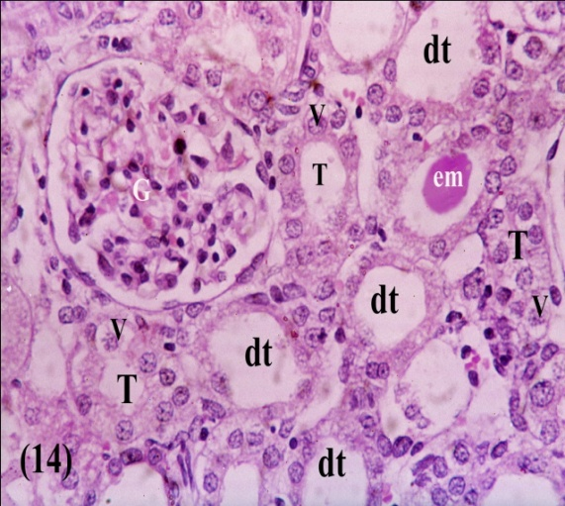
Fig.14: A light micrograph of adult rat kidney treated with Cisplatin plus vitamins C and E showing : Some tubules are dilating (dt) with intact epithelial lining . Other tubules (T)are not dilating but some of their cells having vacuolations (v) .Notice the lumen of one tubule has central esinophilic material (em) . Also, notice intact glomerulus(G) . (HX .&E. X 400)
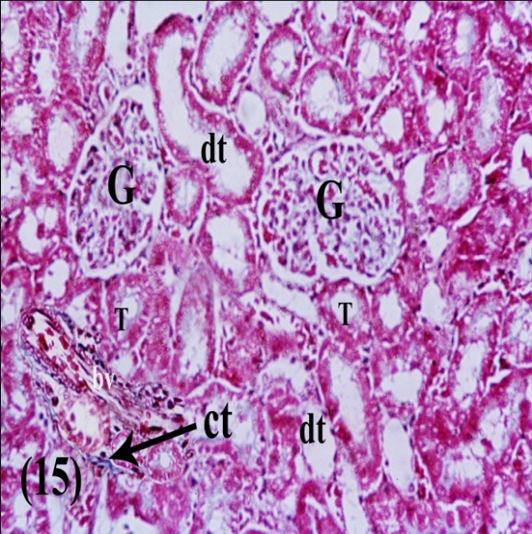
Fig.15: A light micrograph of adult rat kidney treated with Cisplatin plus vitamins C and E showing : Minimal amount of connective tissue (ct) in the interstitial space . Some tubules are dilating (dt) ,while other tubules (T) are intact .Notice intact glomeruli (G) and blood vessel (bv). (Masson´s trichrome x 400)
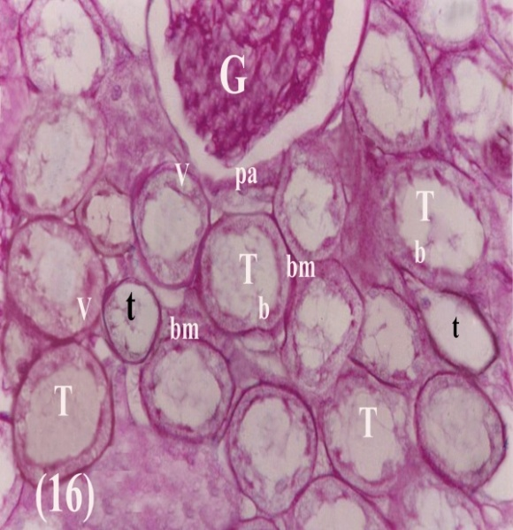
Fig.16: A light micrograph of adult rat kidney treated with Cisplatin plus vitamins C and E showing : Some tubules (T) are dilating with some vacuoles(v)in their cells . Their brush border(b) and the basement membrane (bm) are intact . Few tubules (t) shows degeneration of their epithelial cells with intact basement membrane . Notice intact parietal layer (pa) of the glomeruli (G) . (P.A.S. X400 )
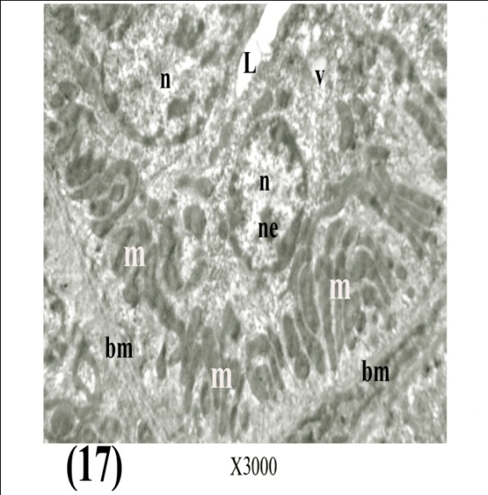
Fig.17: An electron micrograph of adult rat kidney treated with Cisplatin plus vitamins C and E showing : The epithelial cells of the proximal convoluted tubules containing elongated basal striations of the mitochondria (m) ,oval heterochromatic nuclei (n) with nucleoli (ne) and few vacuoles (v) . Notice the lumen (L) and the basement membrane (bm) . (E.M. X 3000)
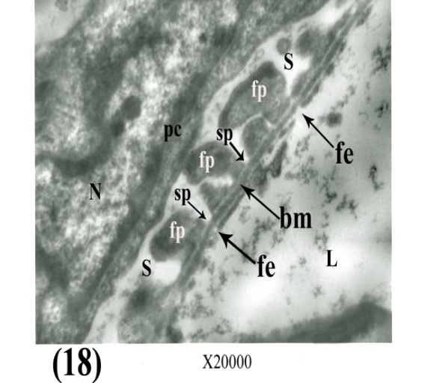
Fig.18: An electron micrograph of adult rat kidney treated with Cisplatin plus vitamins C and E showing : The intact glomerular filter which consisting of fenestrated capillary endothelium (fe), the glomerular basement membrane (bm) and foot processes (fp) of the podocyte(pc) which separated from each other by slit pores (sp) .Notice the capillary lumen(L) ,renal space (s) and the nucleus of podocytes (N). (E.M. X 20,000)

Discussion
The present study deals with the normal structure of the renal cortex of adult rat and the effects of Cisplatin on the renal cortex . Also, this study evaluates the protective effects of vitamins C and E on Cisplatin –induced nephrotoxicity in rats.
In the present study, the histopathological examination of renal sections demonstrated that the Cisplatin produced necrosis of the epithelial cells of the proximal convoluted tubules with subsequent dilatations of their lumens . Some of these tubules contained esinophilic material (cast formation) . The epithelial cells of some tubules contained many vacuoles .These results are similar to the results of ^{(17,18,19,20,21,22)} . Sheikh – Hamad et al. and Uehara et al .who reported that the Cisplatin induced cell injury and necrosis in the rat kidney are predominantly localized in the S3 segment of the proximal convoluted tubules ^{(17,18)} . Sueishi et al. reported that Cisplatin produced vacuolations ,necrosis and protein casts were observed in the proximal convoluted tubules on the fourth day after Cisplatin injection in rats ⁽¹⁶⁾. Cisplatin is mainly excreted by the kidney and the kidney tissue content of this drug is higher than concentrations in other organs . As Cisplatin is retained in the kidney tissue for a long duration ,it may readily cause nephrotoxicity ⁽²³⁾ .
In the present study , Cisplatin induced focal condensation of connective tissue and infiltration of the inflammatory cells in the interstitial space . These data are corroborated by previous studies reported by other investigators on Cisplatin – induced nephrotoxicity in rats ^{(19,20,21,22,24,25,26,27,28)} . Tarladacalisir et al . reported that Cisplatin induced focal mononuclear cell infiltration among some peritubular and Periglomerular areas ⁽²⁷.Guinee et al . observed that these cells are lymphocytes ⁽²⁶⁾ . Martinez et al. reported that the renal interstitial fibrosis is a major complication of Cisplatin treatment ,due to the increased accumulation of extracellular matrix protein ⁽²⁸⁾ .
In the present study , electron microscopic examination of the renal tubular cells showed reduction of the numbers of the mitochondria and the microvilli , while the numbers of lysosomes , vacuoles and vesicles were increased . These are early signs of degeneration of the tubular cells which are similar to the results of previous studies ^{(21,27,29,30,31)} . These previous studies explained the mechanisms of tubular cell damage: As the cell membrane represented the first organelle exposed to the heavy metal (platinum in Cisplatin ),this metal could directly bind to brush border membrane and damage its integrity .This may increase the permeability of the membrane and cause the loss of microvilli . An interaction of heavy metals with the proximal convoluted tubular cell may lead to loss of mitochondria with a release of mitochondrial serin protease with subsequent increasing of the lysosomes ,vacuoles and vesicles ^{(21,27,29,30,32)} .
In the present study , Cisplatin produced electron microscopic changes in the glomerular filter in the form of obliteration of the pores in the glomerular endothelium and obliteration of the slit pores in between the foot processes of the podocytes .These results run parallel with the reports documented by ^{(3,16)} who reported that Cisplatin –induced renal damage is associated with increase in blood urea nitrogen (BUN)and creatinine in serum with increase in the renal vascular resistance.
In the present study , administration of combination of vitamins C and E during the Cisplatin injection reduced the pathological changes induced by Cisplatin. The severity of degenerative changes in the tubular cells and the vascular resistance in the glomerular filter were less than those in the Cisplatin group. Vitamins C and E decreased the tubular necrosis, formation of cast in the tubular lumens ,vacuolations and connective tissue formation .They protect the mitochondria and the glomerular filter from any pathological changes .These findings are similar the results of ^{(14,15,27,32,33)}who reported that the administration of vitamins C and E protect against Cisplatin – induced renal toxicity in animal studies . Vitamins C and E exhibit a protective effect against free radical –induced oxidative damage ^{(34,35)} .
References
1-Meyer KB and Madias NE.(2000):Cisplatin nephrotoxicity .Mine.Electrolyte Metab. 20:201- 203.
2-Van Basten JP, Schrafford-Koop SH , Sleijfer DT,Pras E , Van Driel MF and Hoekstra HJ.(1997): Current concept about testicular Cancer.Eur.J.Surgoncol. 23:354-360 .
3-Antunes LM, Darin JD and Bianchi MD (2001) :Effects of the antioxidants curcumin or selenium on Cisplatin-induced nephrotoxicity lipid peroxidation in rat. Pharmacol.Res.43:145-150 .
4-Gandara DR, Perez EA, Wiebe V and De Gregorio MW.(1991): Cisplatin chemoprotection and rescue . Pharmacologic modulation toxicity .Semin Oncol.18:49-55 .
5-Hamer FPT ,Gispen WH and Neijit JP. (1991): Neurotoxic side effects of Cisplatin Eur. J. Cancer .27:372-376 .
6-Wolfgang GHI ,Dominic MA , Walsh KM , Hoeschele JD and Pegg DG .(1994): Comparative nephrotoxicity of a novel platinum compound , Cisplatin and carboplatin in male wister rats. Fund Apply Toxicol. 22:73-79 .
7-Rybak LP , Ravi PR and Somani SM . (1995): Mechanism of protection by diethyldithiocarbamate against Cisplatin ototoxicity . antioxidant system . Fund Apply Toxicol. 26:293-300 .
8-Durak I , Ozbek H , Karayvaz M and Oztark HS .(2002): Cisplatin induced acute renal failure by impairing antioxidant systems in guinea pig :Effects of antioxidant supplementation on the Cisplatin nephrotoxicity .Drug Chem. Toxicol. 25:1-8 .
9-Yuan JN ,Chao Y ,Lee WP , Li CP, Lee RC ,Chang FY ,Yen SH ,Lee SD and Whang-Peng J. (2008): Chemotherapy with etoposide,doxorubicin ,Cisplatin ,5-fluorouracil and leucovrin for patients with advanced hepatocellular carcinoma .Med .Oncol.25:20-26
10-Sadzuka Y , Shoji T and Takino Y. (1992): Effects of Cisplatin on the activities of enzymes which protect against lipid peroxidation .Biochem.Pharmacol.43:1872-1875
11-Tsao CS .(1997):An overview of ascorbic acid chemistry and biochemistry.In Paker L ,Fuchs J , eds .Vitamin C in Health and Disease .New York : Marcel Dekker,25-58.
12- Frei B , Stocker R , England L and Ames BN. (1990):Ascorbate:The most effective antioxidant in human blood plasma .Adv. Exp. Med. Biol.264:155-163 .
13-Carr A and Frei B .(1999): Does vitamin C act as a pro-oxidant under physiological condition ? FASEB J. 13 :1007-1023 .
14-Ajith TA , Abhishek G , Roshny D and Sudheesh NP .(2009): Co-supplementation of single and multi dose of vitamins C and E ameliorates Cisplatin-induced acute renal failure in mice .Experimental and Toxicologic Pathology .61: 565 -571 .
15-Atasayar S , Gurer-Orhan H , Gurel B , Girgin G and Ozyunes H.(2009): Preventive effect of vitamins C and E on Cisplatin-induced nephrotoxicity in rats .Exp. Toxicol. J .61:23-32 .
16-Sueishi K, Mishima K , Makino K ,Itoh Y , Tsuraya K and Hirakata H (2002): Protection by a radical scavenger edaravone against Cisplatin-induced nephrotoxicity in rats . Eur J .Pharmacol.451: 203-208 .
17-Sheikh –Hamad D ,Cacini W ,Bukley AR ,Isaac J , Truong LD and Tsao CC .,et al .(2003): Cellular and molecular studies on Cisplatin –induced apoptotic cell death in rat kidney .Arch . Toxicol.78: 147 -155 .
18-Uehara T , Watanabe H ,Itoh F , Inoune S ,Koshida H , Nakamura M ,et at .(2005): Nephrotoxin of a novel antineoplastic platinum complex ,nedaplatin :a comparative study with Cisplatin in rats .Arch.Toxicol.79: 451-460 .
19- El-Shazly MO ,Afify MM and El- Dieb MK .(1989): Histopathological study into side-effect toxicity of some drugs used in treatment of cancer.Arch.Exp.Veterinarmed.43:319-326 .
20-Atessahin A , Yilmaz S ,Karahan I , Ceribasi AO and Karaoglu A.(2005): Effects of lycopene against Cisplatin –induced nephrotoxicity and oxidative stress in rats .Toxicology . 212 :116-123 .
21-Choie DD , Longnecker DS and Del Campo AA.(1981): Acute and chronic nephropathy in rats .Lab. Invest. 44: 379 -402 .
22-Mohhan IK ,Khan M , Shobha JC ,et al .(2006) :Protection against Cisplatin –induced nephrotoxicity by spirulina in rats. Cancer Chemother. Pharmacol. 58 :802 -808 .
23-Kawai Y, Taninuchi S , Okahara S ,Nakamura M ,and Gemba M. (2005):Relationship between Cisplatin or nedaplatin-induced nephrotoxicity and renal accumulation .Biol.Pharm.B .28:1385-1388 .
24-Saleh S, and El-Demerdash E.(2005): Protective effects of L-arginine against Cisplatin –induced renal oxidative stress and toxicity :Role of nitric oxide . Basic Clin.Pharmacol. Toxicol.97: 91-97 .
25-Bompart G. and Orfila C .(1990): Cisplatin nephrotoxicity in lead –pretreated rats : Enzymatic and morphological studies . Toxicol.Lett. 50:237-247 .
26-Guinee DG , Van Zee B , Houghton DC .(1993) :Clinically silent progressive renal tubulointerstitial disease during Cisplatin chemotherapy .Cancer. 71:4050-4054 .
27-Tarladacalisir YT , Kanter M .and Uygun M. (2008): Protective effects of vitamin C on Cisplatin –induced renal damage : A light and electron microscopic study . Renal Failure .30:1-8 .
28-Martinez G , Castantino G , Clementi A . and Puglia M.(2009): Cisplatin –induced kidney injury in the rat :L-Carnitine modulates the relationship between MMP-9 and TIMP-3 .Experimental and Toxicolgic. Pathology .61:183-188 .
29-Sugihara K , Nakano S , Koda M ,Tanaka K ,Fukuisfi N and Gemba M .(1987): Stimulatory effect of Cisplatin on production of lipid peroxidation in renal tissues .Jpn J . Pharmacol.43:247-252 .
30-Orfila C , Bompart G , Lepert JC ,Suc JM and Girolami JP(1993) :Renal immunolocalizationof kallikrein in Cisplatin nephrotoxicity in rats. Histochem.25:772-777 .
31-Herak –Kramberger CM.and Sabolic I .(2001): The integrity of renal cortical brush border and basolateral membrane vesicle is damaged in vitro by nephrotoxic heavy metals .Toxicology .156:139-147 .
32-Ajith TA ,Jose N .and Janardhanan KK .(2002) : Amelioration of Cisplatin –induced nephrotoxicity in mice by ethyl acetate extract of a polypore fungus ,Phellimus rimosus J. Exp.Clin. Cancer Res .21:487-491 .
33- Dillioglugil MO , Maral Kit H, Guilkac MD , Ozon Kanli A ,Ozdogan HK .and Acar O.(2005):Protective effects of increasing vitamin E and A doses on Cisplatin –induced oxidative damage to kidney tissue in rats . Urol.Int .75:340 -344 .
34-Fang YZ ,Yang S . and Wu G .(2002): Free radicals, antioxidants and nutrition. Nutrition .18:872-879 .
35-Borek C .(2004): Dietary antioxidant and human cancer Integr. Cancer Ther.3:333-341 .

التأثيرات الوقائية لفيتامين ج ، هـ على الإصابات الضارة الناتجة من استعمال عقار السيسبلاتين على النسيج الكلوي في الفئران البيضاء البالغة
(دراسة بالمجهر الضوئي والإلكتروني )
سعديه أحمد شلبي ، عصام محمد عيد ، نجلاء علي صابر سرج ،محمد مصطفى قنصوه*
قسم التشريح – كلية الطب البشري – جامعة بنها - مصر
مقدمة: يعتبر السيسبلاتين عقار كيماوي فعال يٌستعمل في علاج أنواع متعددة من الأورام الصلبة . ولكن من أكبر التأثيرات الضارة لهذا العقار هو تأثيره السٌمي على الكلى والتي قللت من استعماله في علاج حالات الأورام .
الغرض من هذا البحث: هو دراسة التأثيرات الوقائية لفيتامين ج ، هـ من الأضرار السمية لعقار السيسبلاتين على الكلى في الفئران البيضاء البالغة .
الطرق والمواد : قسم ثلاثون من الفئران الذكور البالغة إلى ثلاث مجموعات :المجموعة الأولى وهي الضابطة ، المجموعة الثانية وهي التي عولجت بعقار السيسبلاتين ،المجموعة الثالثة وهي التي عولجت بعقار السيسبلاتين مع فيتامين ج ،هـ . فئران المجموعة الضابطة حُقنت بمحلول الملح في الغشاء البريتوني مرة واحده يومياً لمدة ثلاثة أيام متتالية . فئران المجموعة الثانية حُقنت بعقار السيسبلاتين في الغشاء البريتوني بجرعة مقدارها 10 مجم /كجم من وزن الفأر مرة واحده يومياً لمدة ثلاثة أيام متتالية . فئران المجموعة الثالثة حُقنت بعقار السيسبلاتين مثل المجموعة الثانية بالإضافة إلى إعطاء هذه الفئران فيتامين ج، هـ عن طريق الفم بجرعة مقدارها 250 مجم/كجم لكل فيتامين قبل إعطاء السيسبلاتين بمقدار ساعة لمدة ثلاثة أيام متتالية. وبعد ثلاثة أيام من آخر حقنة تُذبح فئران المجموعات الثلاث وتحضر للفحص بالمجهر الضوئي والالكتروني .
النتائج : وجد أن عقار السيسبلاتين يحدث تآكلاً في الخلايا المبطنة لمعظم القنيات الملتفة القريبة مع اتساع للتجويف الداخلي لهذه القنيات . بعض تجاويف هذه القنيات احتوت على مادة ملونة بلون أحمر .ويوجد في بعض الخلايا تجاويف فارغة . هذا العقار أحدث زيادة في كثافة الأنسجة الليفية ورشح للخلايا المسببة للالتهاب في بعض الأماكن . وعند الفحص بالمجهر الإلكتروني وجد أن السيسبلاتين أدى إلى نقص في عدد الميتوكوندريا والخملات مع زيادة في عدد الأجسام المحللة والتجاويف الفارغة والممتلئة بالمواد المتحللة .ووجد أيضاً انسداد في الثقوب البينية في الغشاء المبطن للشعيرات الدموية للكبيبات الكلوية وكذلك انسداد في الثقوب البينية لزوائد الخلايا القدمية . ومع تعاطي فيتامين ج، هـ أثناء العلاج بعقار السيسبلاتين ،وجد نقص في التغيرات النسيجية الضارة من استعمال السيسبلاتين إذا ما قورنت بالمجموعة الثانية .
الاستنتاج: نستنتج من هذه الدراسة أن التأثيرات السٌمية لعقار السيسبلاتين على الكلى قد تم تقليلها عند استعمال فيتامين ج ، هـ أثناء العلاج بهذا العقار .

